WIKWEMIKONG TRIBAL POLICE SERVICES BOARD
WIIKWEMKOONG UNCEDED INDIAN RESERVE NO.26
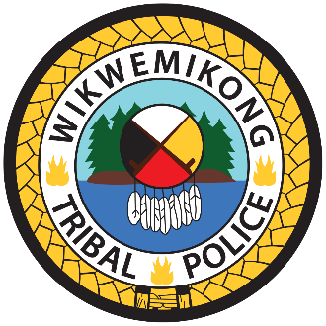
MINUTES OF THE REGULAR BOARD MEETING
The Special Meeting of the Wikwemikong Police Services Board was held via Teams on February 18, 2026 at 6:00 p.m.

PRESENT:
Board: Joseph Wabegijig
Peggy Manitowabi
Terry Beaudry
Lynda Trudeau - 6:11 pm arrival
Lawrence Enosse – 6:33 pm

Guest: Rachael Paquette, Paquette & Associates

#032-02-2026 By Consensus
THAT the Special Meeting of the Wikwemikong Police Services Board be opened for business at 6:00 p.m., with a quorum of members present, with Peggy Manitowabi presiding in the Chair.
CARRIED

Purpose of meeting was to discuss and review amendments to the WTPS Board By-law.

ADJOURNMENT
#033-02-2026 By Consensus
THAT we adjourn until the next meeting at 9:45 p.m. or Call of the Chair.
CARRIED

________________________ _____________________________
Peggy Manitowabi, Chair Terry Beaudry, Board Member
*These Minutes have been circulated but are not considered Official until approved by the Board.
Recorded by: Jackie White
Next meeting: March 5, 2026 at 6:00 p.m.

